TOPIC: E-CRIME MANAGEMENT SYSTEM
NAME: SRUTI VERMA
REGISTRATION NUMBER:18BCE1005

STATE DIAGRAM: POLICE 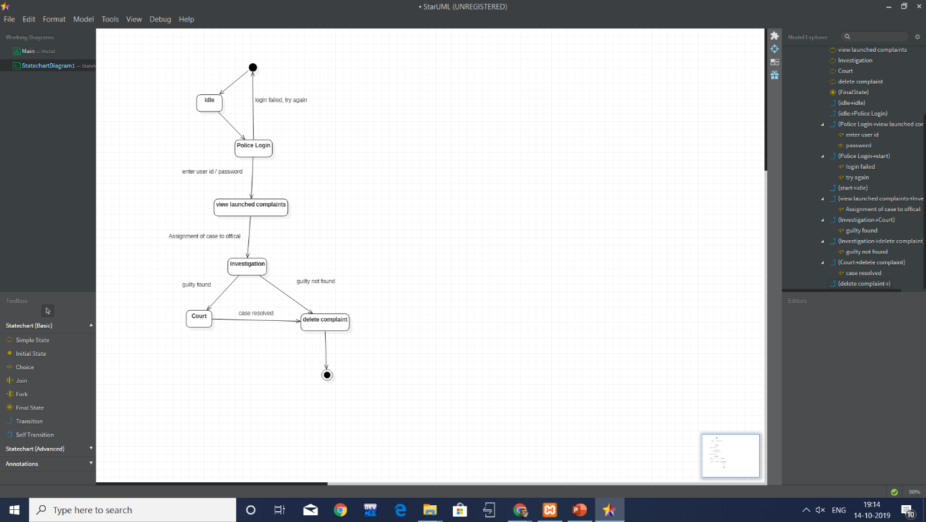

STATE DIAGRAM FOR USER
